SE Assignment

**What is software? What is software engineering?**

The term software engineering is composed of two words, software and engineering. Software is more than just a program code. A program is an executable code, which serves some computational purpose. Software is considered to be a collection of executable programming code, associated libraries and documentations. Software, when made for a specific requirement is called software product.

Engineering on the other hand, is all about developing products, using well-defined, scientific principles and methods.

So, we can define software engineering as an engineering branch associated with the development of software product using well-defined scientific principles, methods and procedures. The outcome of software engineering is an efficient and reliable software product.

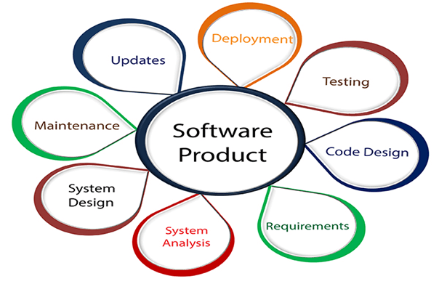

**Explain types of software**

Software is used to control a computer. There are different types of software that can run on a computer: system software and application software.

Let’s take a closer look at them.

**1. System software**

If you think of software as being in layers, the system software is the bottom layer: it sits between the hardware and the application software.

Operating systems like Windows, macOS, Android and iOS are examples of system software. Operating systems are loaded into RAM when the device starts up, and have access to the hard drive.

**2.Application software**

This is everything else! Anything that is not an operating system or a utility is an application or app. So a word processor, spreadsheet, web browser, and graphics software are all examples of application software, and they can do many specific tasks.

You can remove and add applications on your computer using the operating system.

Application software like a word processor regularly directs the operating system to load and save files from and to the hard drive. When you are working on a file, it is saved temporarily in the RAM. It is only when you choose to save it that it is written to the hard drive.

This is why, if the computer crashes while you’re working on a file, you may lose any changes you didn’t save. Data stored in the RAM is volatile. The data is lost when the RAM loses power.

**What is SDLC? Explain each phase of SDLC.**

A software life cycle model (also called process model) is a descriptive and diagrammatic representation of the software life cycle. A life cycle model represents all the activities required to make a software product transit through its life cycle phases. It also captures the order in which these activities are to be undertaken. In other words, a life cycle model maps the different activities performed on a software product from its inception to retirement. Different life cycle models may map the basic development activities to phases in different ways. Thus, no matter which life cycle model is followed, the basic activities are included in all life cycle models though the activities may be carried out in different orders in different life cycle models. During any life cycle phase, more than one activity may also be carried out.

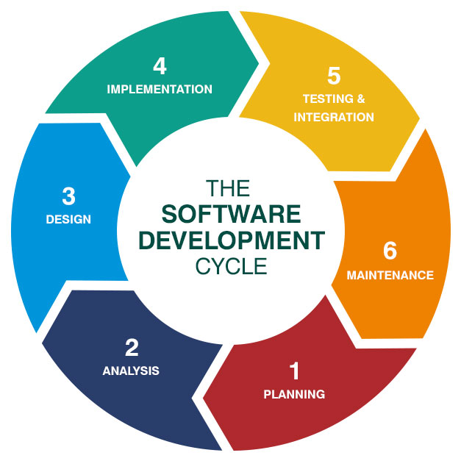

**What is DFD? Create a DFD diagram on Flipkart.**

A data-flow diagram is a way of representing a flow of data through a [process](https://en.wikipedia.org/wiki/Process) or a system (usually an [information system](https://en.wikipedia.org/wiki/Information_system)). The DFD also provides information about the outputs and inputs of each entity and the process itself. A data-flow diagram has no control flow — there are no decision rules and no loops. Specific operations based on the data can be represented by a [flowchart](https://en.wikipedia.org/wiki/Flowchart).

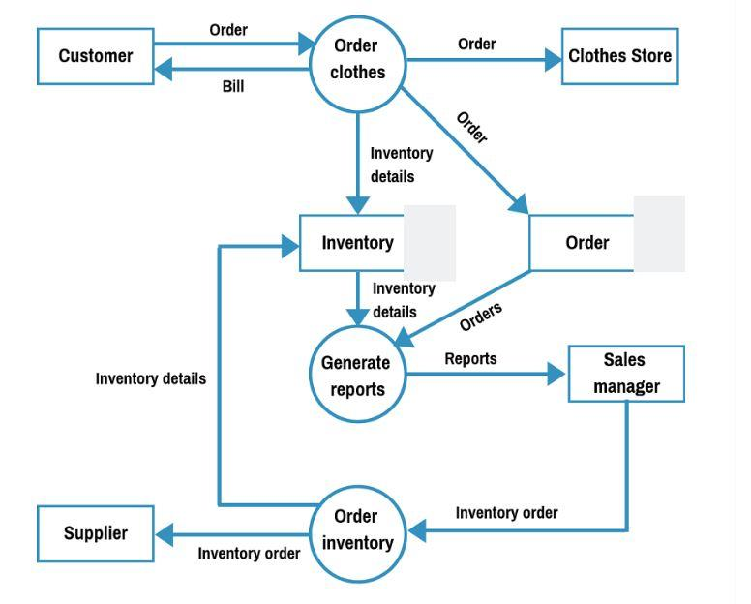

**What is Flow chart? Create a flowchart to make addition of two numbers**

A flowchart is a type of [diagram](https://en.wikipedia.org/wiki/Diagram) that represents a [workflow](https://en.wikipedia.org/wiki/Workflow) or [process](https://en.wikipedia.org/wiki/Process). A flowchart can also be defined as a diagrammatic representation of an [algorithm](https://en.wikipedia.org/wiki/Algorithm), a step-by-step approach to solving a task.

Flowcharts are used to design and document simple processes or programs

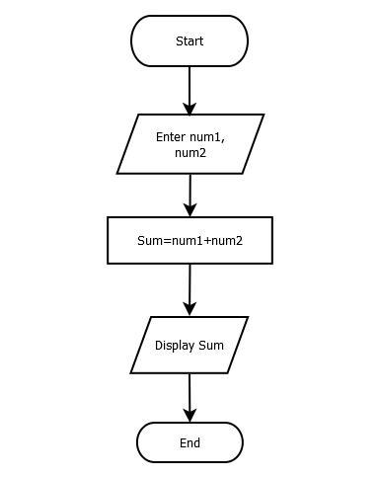

**What is Use case Diagram? Create a use-case on bill payment on paytm.**

The use case model for any system consists of a set of “use cases”. Intuitively, use cases represent the different ways in which a system can be used by the users. Use cases correspond to the high-level functional requirements.

